
Mathematics Department

11 Maths Methods Test 4 Odd

Trigonometry Graphs, Cubics, Probability and Circle Measures
Name
Section 1 – Resource Free
Marks : 30 Time: 30 minutes (maximum)

1. [5 marks]

For the graph of y = x³ - x² - 4x + 4, determine:
(a) the coordinates of the point where the curve cuts the y-axis,

(b) the coordinates of the points where the line cuts the x-axis.

(c) Draw a sketch of this graph.

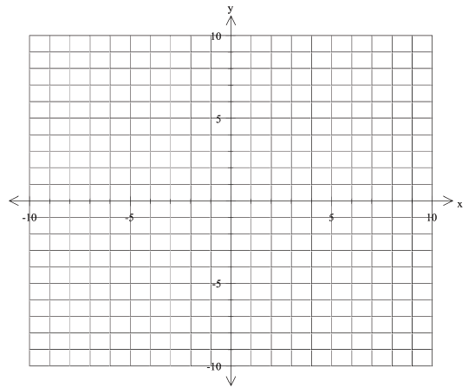

2. [1, 2 marks]

(a) Express in radians leaving your answer as a multiple of

(b) Express radians in degrees

3. [2 marks]
Match each graph with its corresponding equation below.

(i) ______________________
(ii) ______________________
(iii) ______________________

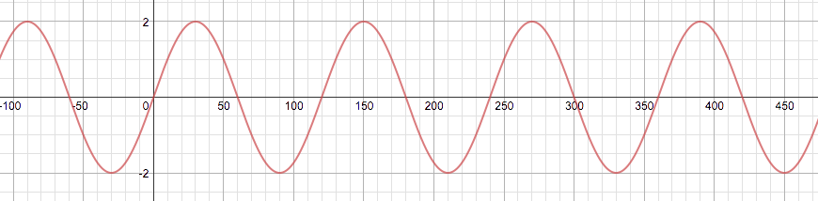

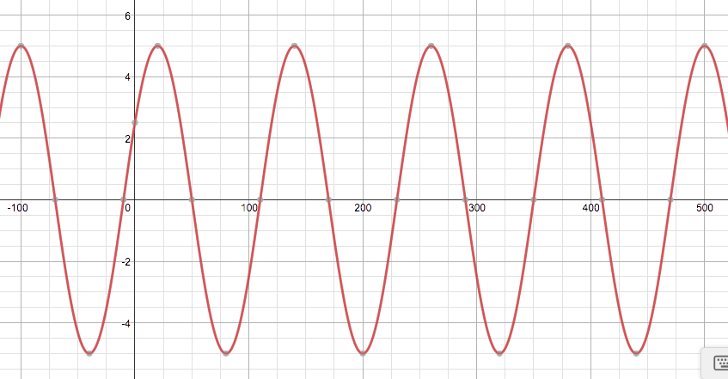
6. Give the amplitude, period and highest and lowest values for each of the following:

a) ; Amplitude ____ Period ____

b) ; Amplitude ____ Period ____

c) ; Amplitude ____ Period ____
[3]
7. Give the period of each of the following functions:

a) ; Period ____
b) 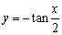 ; Period ____
c) ; Period ____ [2]

Question 5 (8 marks)
The graph of a trigonometric function is shown below.

(a) Clearly circle all of the functions listed below that could be. (5 marks)

Question 7 (6 marks)
The graphs of the functions are shown below, where are real constants.

State the values of constants .


Mathematics Department

11 Maths Methods Test 4 Odd

Trigonometry Graphs, Cubics, Probability and Circle Measures
Name
Section 2 – Resource Rich
Marks : 29 Time: 30 minutes (minimum)

6. [5 marks ]

Some Year 12 students purchased 30 items from two surf shops; High Tied and Surf Down.

The following table shows how many Tops, Shorts and Jeans were purchased from each shop.
 | Tops | Shorts | Jeans
High Tied | 4 | 9 | 4
Surf Down | 3 | 8 | 2

Two items were chosen at random from the group of 30.

(a) Determine how many different ways there are of choosing the two items. [1]

Without evaluating answers, find the probability that:

(b) they were both from High Tied. [1]

(c) one was from each shop. [1]

(d) neither was a top from High Tied. [1]

(e) neither was a top and neither was from High Tied. [1]

Question 5 [5 marks]

Given , P(A) = 0.4 and P(B) = 0.5,

a) find (2)

b) find P(A|B) (2)

c) Are events A and B independent? (Justify your answer) (1)

Question 4 [5 marks]
A deer farmer believes that the profit/loss of his farm may be affected by weather conditions. His computer is set up with appropriate software and the following table produced.

 | Weather Favourable  (F) | Weather Unfavourable  ()
Profit (P) | 0.52 |  | 0.65
Loss () |  | 0.23
 | 0.64 |  | 1.00

- Complete the table. (2)
- Find the probability that he makes a profit and the weather is unfavourable. (1)

(c) Find the probability that the weather was favourable, given that he makes a loss. (2)

4. [4 marks]
Calculate the area of the shaded region

6. [6 marks]

A sector has a perimeter of 28 cm and area of 48 cm². Find the radius and central angle of each of the possible sectors.

Question 7 (7 marks)

The diagram below shows a pair of intersecting circles with centres at P and Q with radii of 5 cm and 6 cm respectively. RS is the common chord of both circles and PQ is 7 cm.
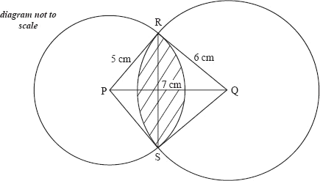
Find the area of the shaded region.

8. [7 marks]

A sector of a circle is shown in the diagram opposite.

a) If r = 8cm and θ = 50°, find the perimeter of the sector
(accurate to 1 decimal place).

b) If the radius is 9cm and the perimeter is 31.5 cm, find the size of θ in radians.

c) Given that the area of the sector is 62cm² and θ = 1.4 radians. Find the radius of the sector (accurate to 2 significant figures).

5. [4 marks]

A sector has a perimeter of 28 cm and area of 48 cm². Find the radius and central angle of each of the possible sectors.

Question 12 (9 marks)
For two events, and , , and .

(a) Determine an expression for in terms of . (2 marks)

(b) State the maximum possible value of . (1 mark)

(c) Determine the value of under each of the following conditions.

(i) and are mutually exclusive. (1 mark)

(ii) . (2 marks)

(iii) is independent of . (3 marks)

Question 13 (8 marks)
The clinical records of a large eye hospital indicate that

- 58% of patients are blue eyed (set )
- 42.9% of patients belong to the blood group O (set )
- 31.9% of patients are blue eyed and do not belong to blood group O

(a) Use this information to complete the probabilities to in the tree diagram below.
(4 marks)

(b) What is the probability that a randomly selected patient will

(i) belong to blood group O and have blue eyes? (1 mark)

(ii) have blue eyes or belong to blood group O? (1 mark)

(iii) not have blue eyes, given they do not belong to blood group O? (2 marks)

Question 18 (7 marks)
After a storm had passed, a yachtsman noticed that the labels had washed off 18 identical cans of food stored below deck. The yachtsman knows that six of the cans contain lamb stew and the remainder contain beef stew. The yachtsman selects four of the cans at random.

(a) What is the probability that all four cans selected contain beef stew? (2 marks)

(b) What is the probability that no more than two cans selected contain lamb stew? (3 marks)

(c) The yachtsman opens two of the four cans selected and finds that they both contain beef stew. What is the probability that all four selected contain beef stew? (2 marks)

